Final Project: Nobel Prize Laureates Data Analysis

Hunter H. Davis
American Public University System
DATS255: Data Visualization

Nobel Prize Laureate Data Analysis
The Nobel Prize laureates data set used in my analysis covers awardees from 1901 to 2023 across six distinct categories (Chemistry, Economics, Literature, medicine, Peace, and Physics). Recorded information in the data set includes the reason for the award, awardees name and affiliation, birth/death city and country, gender, birth/death date. The data set source was obtained from an internet search, but I forgot to save it, so I had to track down a different source for the same dataset, which I found on Kaggle.

Research Questions
I started this project with the goal of answering the following research questions:
- Does an individual’s/groups’ nationality increase/decrease their odds of receiving the Nobel Prize?
- What is the average age of a Nobel Prize recipient?
- Which category is most/least likely to receive the Nobel Prize?
- Has an individual recipient (not an organization) received more than one Nobel Prize in the same or a different category?
I originally thought that I wouldn’t have any more questions about the data set when first designing this project, but I came to find out that that was naive of me. The Nobel Prize data set had a surprising amount of information beyond what I saw on the surface. I was able to explore beyond my original questions and look at trends and patterns present that I hadn’t considered.

Data Analysis Methods
I first tackled the issue of different formatting methods for the birth and death dates by parsing out just the year and converting the object type into int64. This allowed me to better assess the age of each laureate at the time of their award (year awarded – birth year), month and days were disregarded for simplicity. Prize share information was factorized for easy analysis by encoding the string values. Gender, birth city, birth country, death city, death country, organization city, organization country, and the type of laureate (individual or organization) was similarly encoded. This wasn’t strictly necessary, but I thought it might be helpful if I needed to model some of these values in the future. Various types of plots and charts were used to better understand the distribution of laureates’ demographics. Standardization of country names was implemented for birth countries to better assess which countries produced the most Nobel prize winners.

Findings and Conclusions
Age Metrics of Nobel Prize Winners (Table 2 & 3, Figure 1 & 4):
- Average age of a Nobel prize laureate: 60.3 years of age.
- Youngest laureate: 17 years of age (awarded the Peace prize)
- Oldest laureate: 97 years of age (awarded the Chemistry prize)
- Physics has the youngest average age at time of award at 57.3 years of age.
Category metrics (Table 2):
- Medicine is the most likely category to be awarded a Nobel prize with 227 awards (physics a close second at 224).
- Economics is the least likely category to be awarded a Nobel prize with only 93 awards (most likely due to only being introduced as a category in the year 1969).
Odds of receiving a Nobel prize (Table 1, Figure 9, 10, 11):
- Affiliation with a top university in the USA greatly improves one’s chances of receiving a Nobel prize as 9 of the top ten universities are from the USA.
- There are six awardees (2 organizations and 4 individuals) who have received multiple Nobel prizes from 1903 to 1981. Only two of which received awards in different categories.

Interesting findings (Figure 2, 3, 5, 6, 7, 8, 12):
- Overwhelmingly Nobel prize winners are male, of the 970 recipients only 65 were female.
- Females have been awarded the Nobel peace prize (19) the most out of all the categories, with literature a close second (17).
- Female representation has slowly increased each decade, besides in the 1950’s, with the 2020’s numbers already matching those of the 2000’s.
- The majority of all Nobel prize winners come from the USA, with the other 9 of the top ten countries all hailing from Eastern Europe except for Canada (9th) and Japan (7th).
- The average age of Nobel prize recipients since the 1960’ has been increasing for males, while the female recipients have seen a slight decrease in average age over the same time period.
- Average prize share per category has been increasing, indicating that less individual persons are being awarded Nobel prizes. The only category that contradicts this is Literature, which has maintained individual awards since the 1960’s.

References
- Islam, S. (2023). Nobel Prize Winners: 1901 to 2023. Kaggle.com. https://www.kaggle.com/datasets/sazidthe1/nobel-prize-data

Tables
Table 1
Table of individuals and organizations that have one multiple Nobel Prizes.
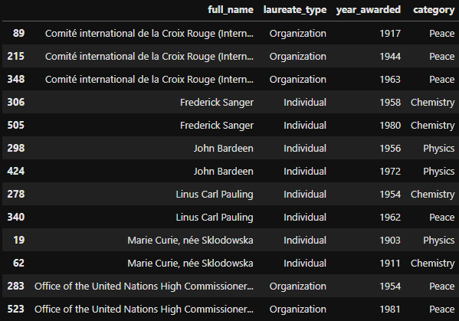

Table 2.
Distribution data of laureates ages at the time the Nobel Prize was awarded and count of awards per category.
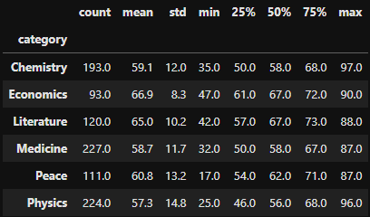
Table 3.
Age at time of award metrics.
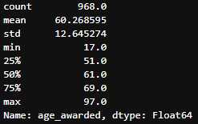

Figures Title
Figure 1.
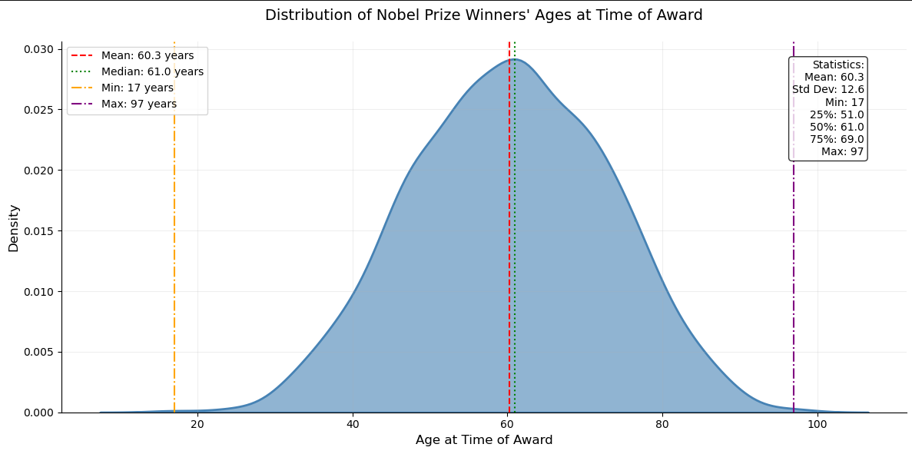
Figure 2.
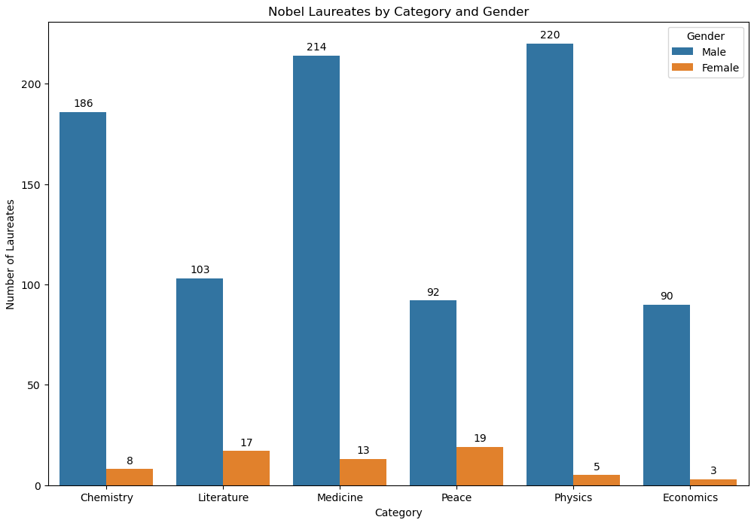

Figure 3.
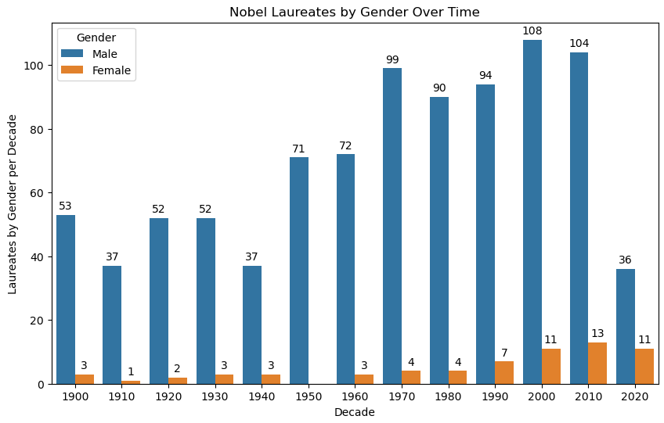
Figure 4.
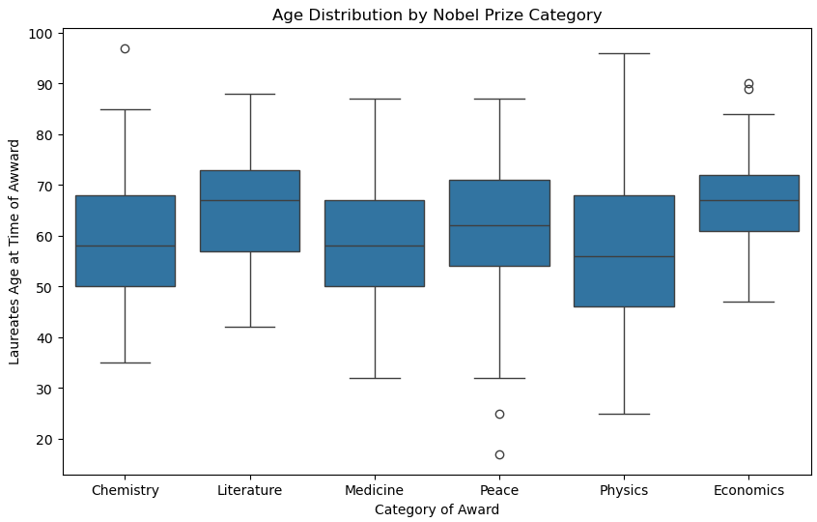
Figure 5.
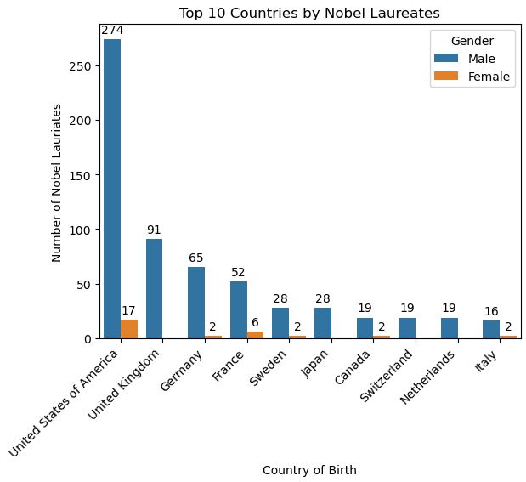
Figure 6.
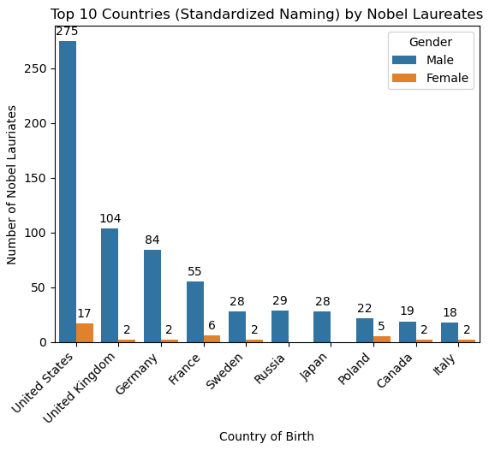

Figure 7.
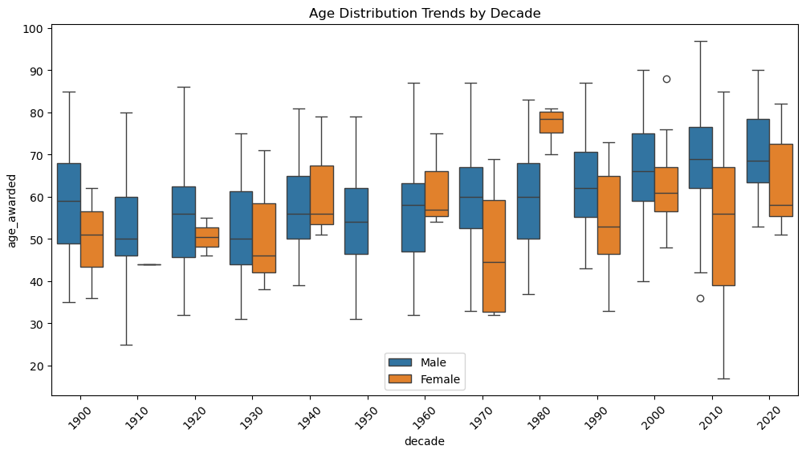
Figure 8.
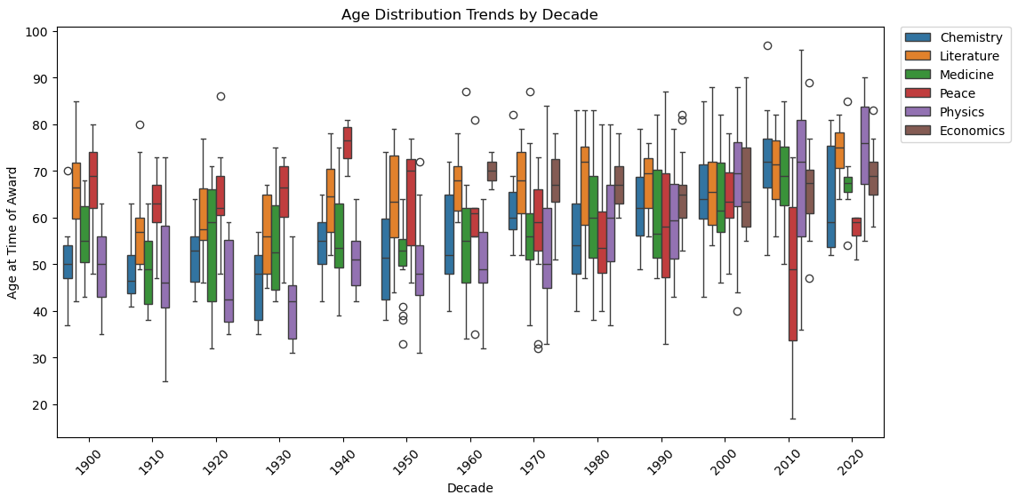

Figure 9.
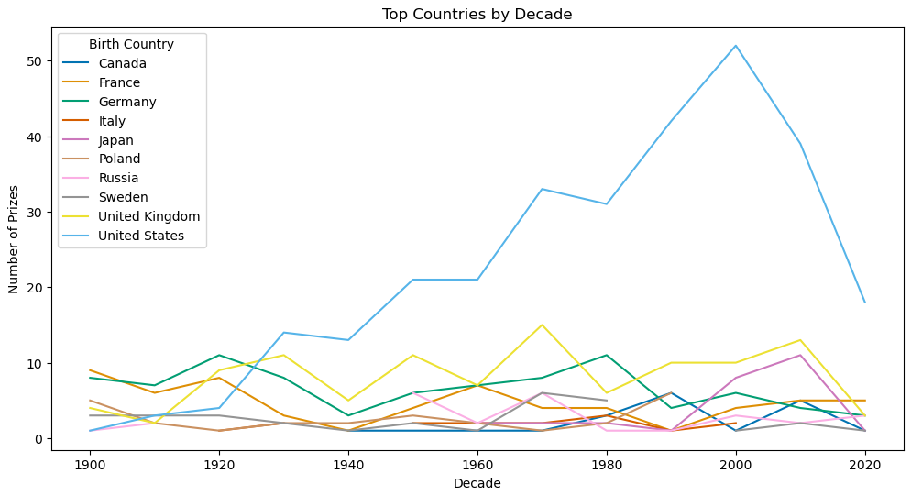
Figure 10.
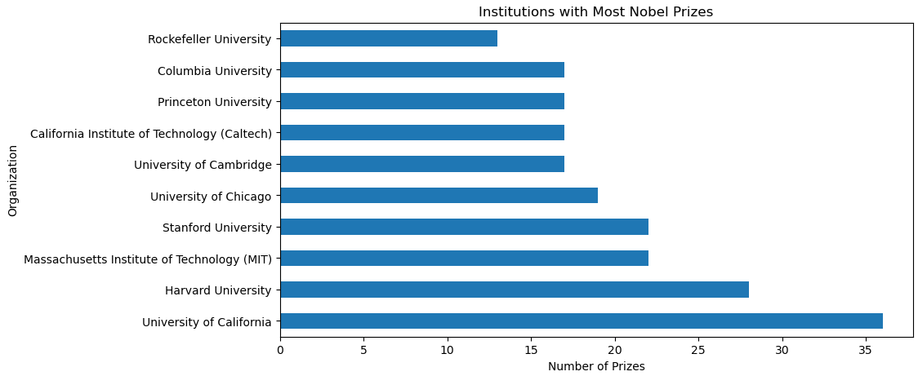

Figure 11.
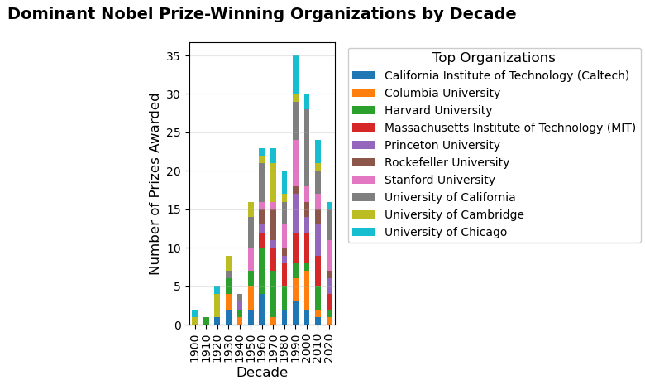
Figure 12.
